NAME: SAGARSUMAN P MANJHI SUBJECT: PYTHON PROGRAMMING LAB | PRACTICAL: 02 | BATCH : 04  SYBVOC :SEM-III (DS)
Experiment based on Tuple, Dictionary and Set Data Structures

AIM : To write a Python program to demonstrate the use of different structures—Tuple, List, Set, and Dictionary—for storing adisplaying student information such as name, roll number, subjhobbies, and marks, along with performing basic operations linsertion, deletion, searching, updating, and traversal.
LEARNING OBJECTIVE :
  - To understand Python data structures.
  - To learn the use of Tuple, List, Set, and Dictionary.
  - To store and display student information.
  - To improve programming and logical thinking skills
TOOLS :

Sr. No. | Name Of Resources | Specification | Quantity | Remarks
1. | Hardware | Computer (i5-i7) Ram (Min 16GB) | 1 | For All Practical
2. | Software | Python / IDLE / VS Code | 1 | For All Practical
THEORY :
1. Tuple: A Tuple is an ordered and immutable collection of elements.
Example:
student = ("SAGARSUMAN MANJHI", 101)
2. List
A List is an ordered and mutable collection of elements.
Example:
subjects = ["Python", "Maths", "Java"]
3. Set
A Set is an unordered collection of unique elements.
Example:
hobbies = {"Music", "Cricket", "Reading"}
4. Dictionary
A Dictionary stores data in key-value pairs.
Example:
marks = {
"Python": 85,
"Maths": 80,
"Java": 75
}

Source Code:
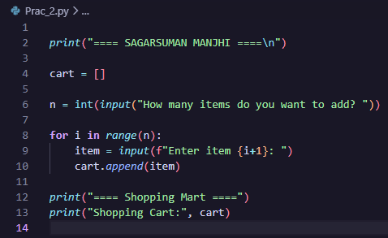
Output:
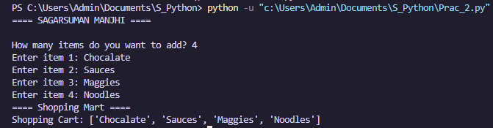
Result and Discussion:
The program successfully accepted multiple shopping items from the user and stored them in a list using the append() method. A for loop was used to accept the items and display the shopping cart.
Learning Outcomes:
- Understood the concept of lists in Python.
- Learned to use for loop and append().
- Learned to store multiple items in a list
Course Outcomes:
- Learned to create Python programs using lists and loops.
- Understood basic data storage and iteration.
- Improved logical and programming skills.
CONCLUSION :
The Shopping Cart program successfully demonstrates the use of a list, for loop, and append() method in Python. It helps in understanding how multiple items can be stored and displayed easily.

VIVA QUESTIONS :
1. What is a data structure?
A data structure is a method of organizing and storing data so that it can be accessed and modified efficiently.

2. What is a list in Python?
A list is an ordered and mutable collection of elements. It is written using square brackets [].
Example:
cart = ["Laptop", "Mouse", "Keyboard"]

3. What is a string?
A string is a sequence of characters enclosed in single or double quotation marks.
Example:
name = "Laptop"

4. What is the use of append()?
The append() method adds a new element to the end of a list.
Example:
cart.append("Mouse")

5. What is indexing?
Indexing is used to access an individual element of a list or string using its position.
Example:
cart[0]
The first element has index 0.

FOR FACULTY USE ONLY :
Correction Parameters | Formative Assessment [40%] | Timely completion of practical [40%] | Attendance/ Learning Attitude [20%]
Marks Obtained

